**Workshop: Cubicle – Part 4**

"*Cubicle*" is a place, where you can browse some of the most popular Rubik's cubes in the world and add some new cubes that you have discovered.

This is the final part of the workshop, so if you missed some parts, make sure you complete them before you continue because all parts of this workshop are related to each other.

**Main Task**

As a final step, you should implement some validation, notification to improve the user experience and protect the data that is stored in the database.

**Installing Dependencies**

You can use [**express-validator**](https://www.npmjs.com/package/express-validator)to do some **validation** and **sanitization** or continue using Mongoose to do validations as well.

## Validations

### User

Before some users register or login, implement the following validations:

* **Username**
  + Should be **unique** (add "**unique: true"** property to each **User** **Model** username)
  + Should consist only of **English letters** and **digits**
  + Should be at least **5 characters** long
* **Password**
  + Should consist only of **English** **letters** and **digits**
  + Should be at least **8 characters** long
* **Re-Password** - (only in Register Page)
  + Should be the **same** as the given password

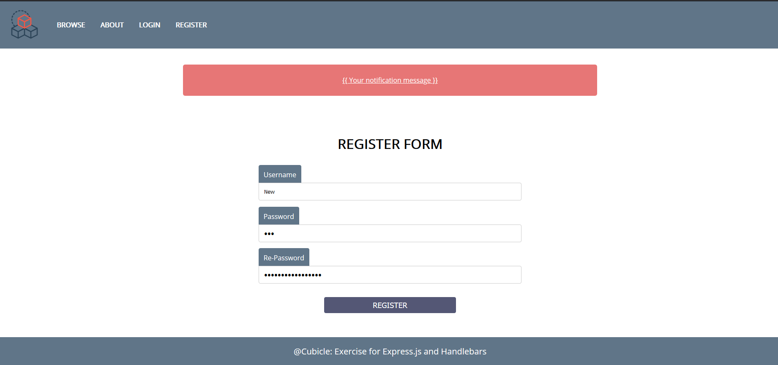

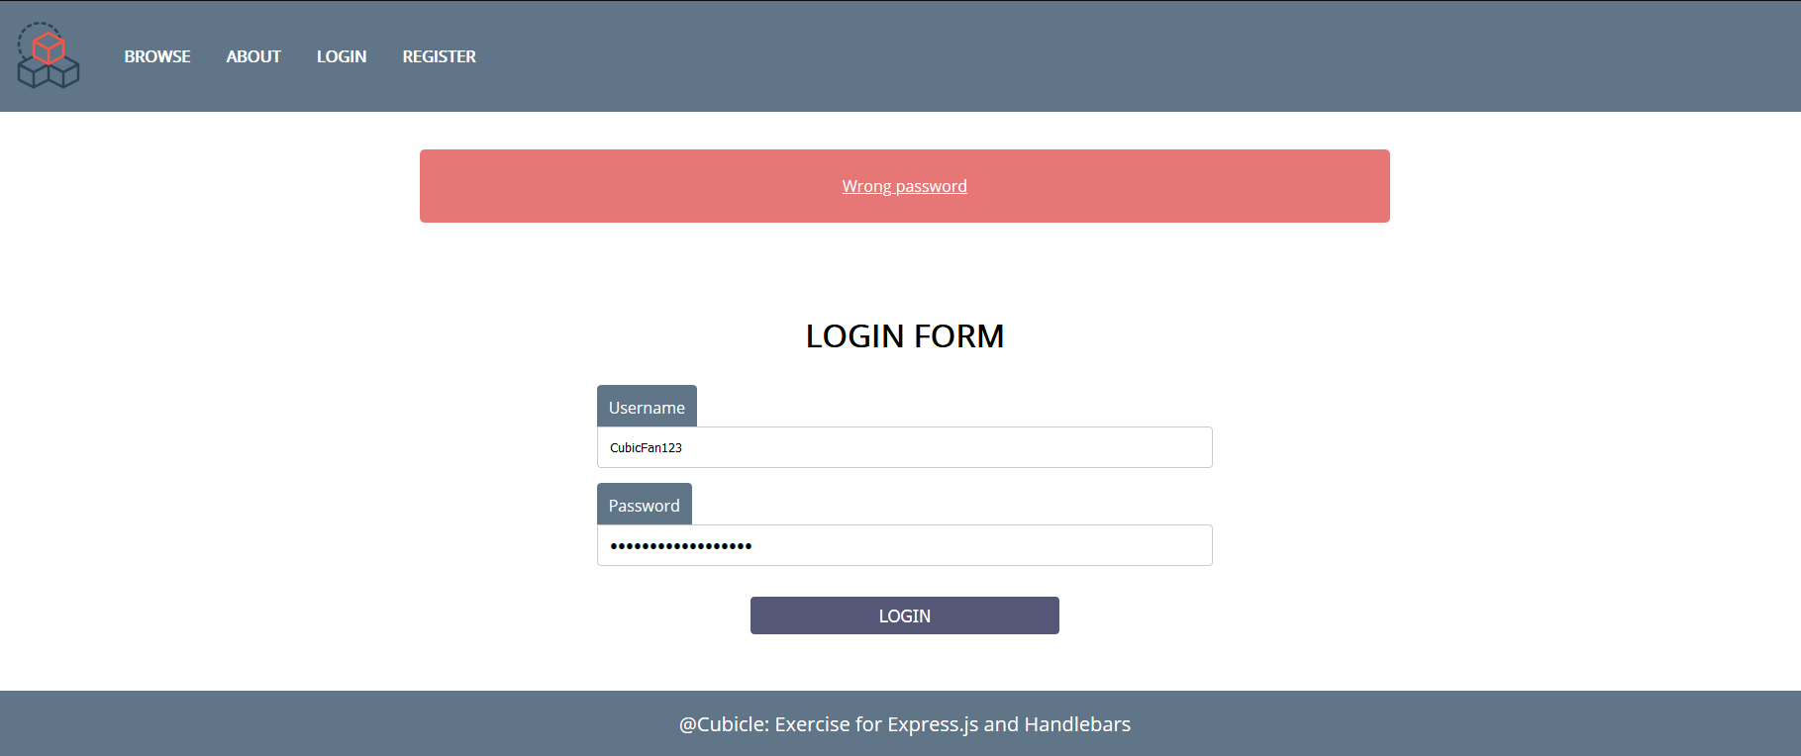

### Cube and Accessory

The **cube** and **accessory** forms also should have some validation:

* **Name** - At least **5 characters long**, who could be **English** **letters**, **digits,** and **whitespaces**
* **Description** - At least 20 characters, who could be **English** **letters**, **digits,** and **whitespaces**
* **ImageUrl -** Referring to actual picture (starts with **http://**... or **https://**...)

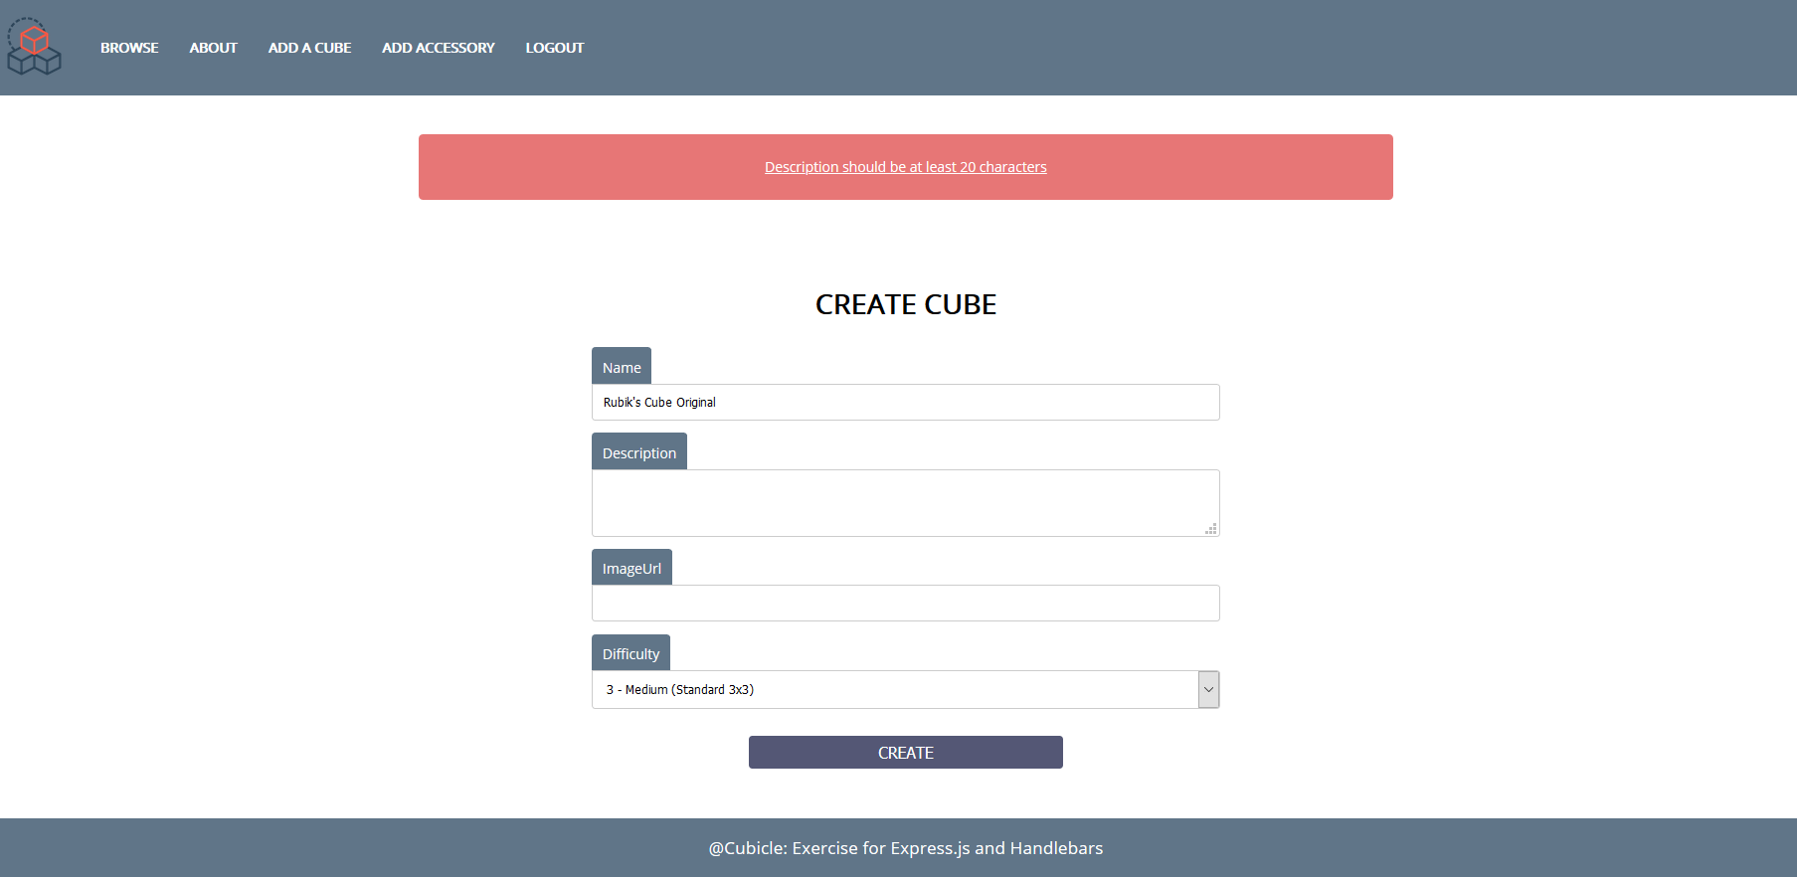

**Error Handling**

In case of errors, for instance, If the given username is **already** **taken, does not exist** or the given **password** (while login) is **incorrect**, handle the error properly and show an appropriate notification.

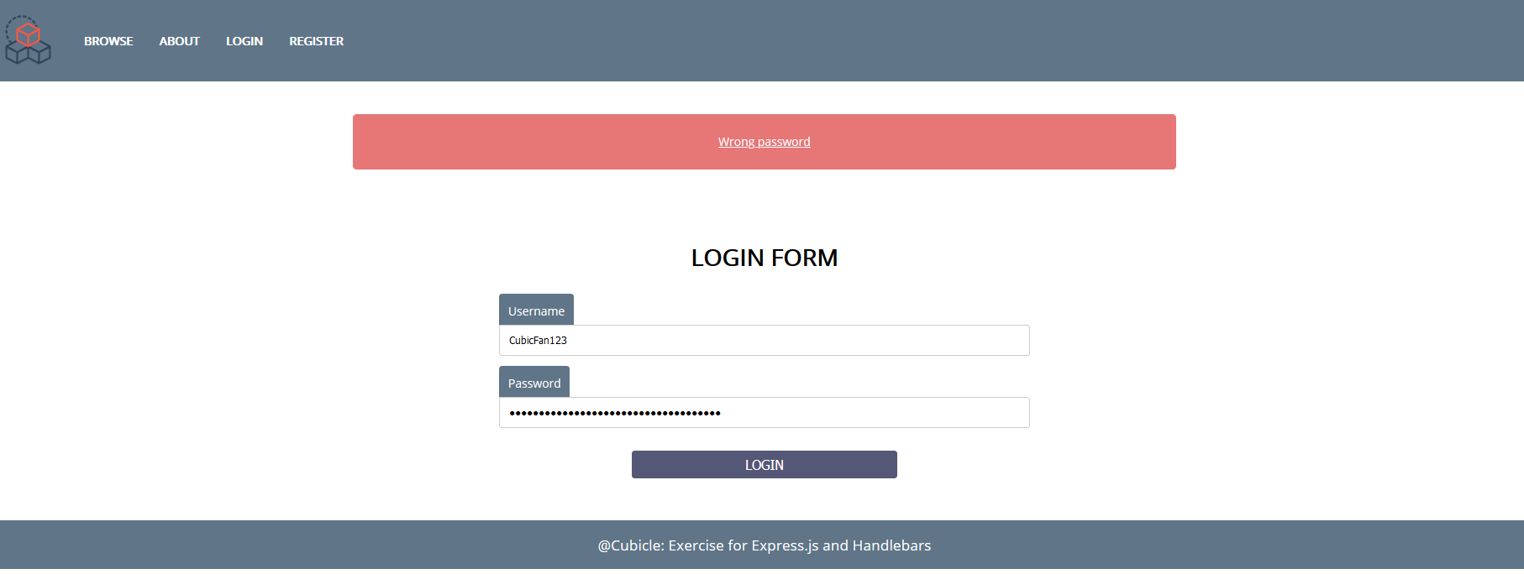

**Template Update**

If you want to use the notifications which are shown in the pictures, you should modify a little your **main layout hbs** file. Create a **div** with **id**="**notifications"**, between the **header** and the **main** element, which holds a single **paragraph** with **id**="**notification-message**". Check the picture below:

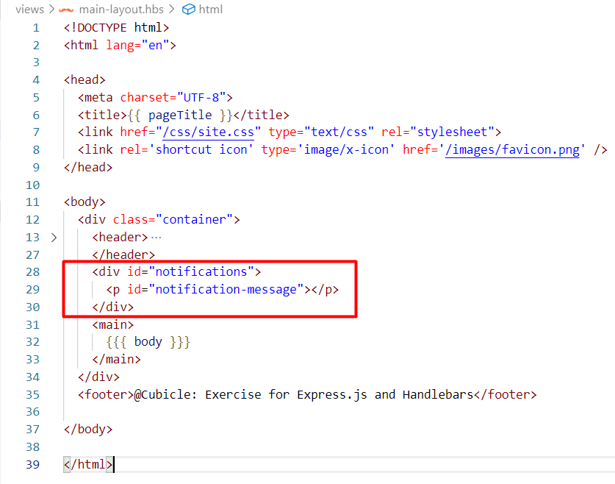

Also, you should append the following styles into the **site.css** file

#notifications {

    margin: 0 auto;

    margin-top: 0px;

    margin-bottom: 0px;

    text-align: center;

    width: 50%;

    padding: 0.5%;

    margin-top: 2%;

    margin-bottom: 2%;

    background: rgb(231, 118, 118);

    color: white;

    border-radius: 5px;

    text-decoration: underline;

}

**Good Luck! 😊**